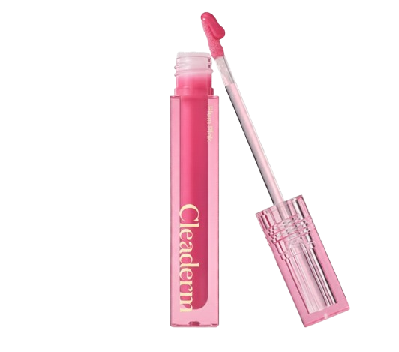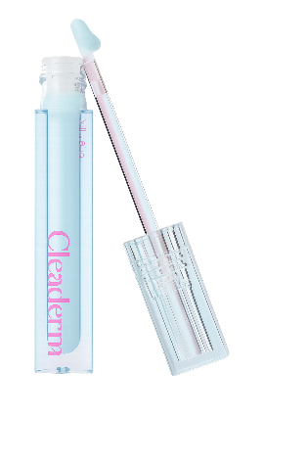
Name : Cleaderm
Cleaderm small molecule collagen glow lip serum
- Milky blue
- Plum pink
Description :
A viscous , collagen textured lip serum that forms a milky layer to blur and plump lip wrinkles , giving a dewy , moisturized look.
Direction :
Spread evenly across the lips.

